Newsletter

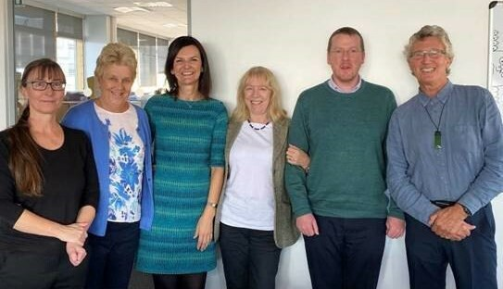
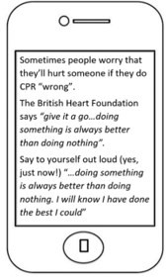
Volume 4, Issue 1. 31/01/22

In brief:
- The MAP study, run by Helen Cheyne, Margaret Maxwell, Andrea Sinesi and Cath Best in collaboration with researchers at City, University of London, has successfully completed
recruitment in November 2021 with a total of 2245 participants recruited between England and Scotland.

- Professor Anne Whittaker
was delighted to see the publication of the final report for the
PuP4Dads
feasibility study in
NIHR PHR Journal

Inside this issue:
Developing a 1
Behavioural
Intervention to Increase CPR Performance
By Dr Barbara Farquharson

Best clinical 1
abstract award at
International
Continence Society conference
by Professor
Suzanne Hagen

Research 2
Partnership Group: Reflection on 2021 By Shelia Cameron, RPG Chairperson

Developing a Behavioural Intervention to Increase CPR Performance
By Dr Barbara Farquharson

The BICeP Study funded by the MRC and led by Dr Barbara Farquharson from NMAHP-RU completed at the end of 2021. The aim of this study was to develop text-messages with embedded behaviour-change
techniques to increase lay-people’s intentions to initiate CPR. The messages (35 in total)
were developed in close collaboration with members of the public and expert advisors.
The team were delighted to be able to share the final
intervention and to discuss positive results from initial pilot study at a stakeholder event on 5th November.
Following supportive discussions at that event the team are now proceeding with plans to seek funding for a full-scale evaluation.

Best clinical abstract award at International Continence Society conference
By Professor Suzanne Hagen

Professor Suzanne Hagen, alongside NMAHP-RU colleagues Andrew Elders and Ceri Sellers presented the paper 'Pelvic floor
dysfunction 26 years after
childbirth: a longitudinal
study' at the International
Continence Society conference 2021. The conference abstract reporting the first findings of theProLong20+ study was awarded the best clinical abstract by the conference organisers.
This unique longitudinal follow-up of women from Aberdeen and Birmingham after childbirth has shown higher prevalence of pelvic floor dysfunction at 26 years
12 years. While there is an indication that a delivery history of exclusive caesarean sections may be associated with a reduced risk of experiencing symptoms of pelvic floor dysfunction, the prevalence of urinary incontinence remains high with almost half of women reporting this
symptom. The findings will be further informed by a full longitudinal statistical modelling analysis of these data, adjusting for demographic characteristics, inclusion of data from the New Zealand cohort members and an analysis of responder and non- responder characteristics.

following index birth than at
Ceri Sellers, Professor Christine Macarthur, Professor Suzanne Hagen, Professor Charis Glazener, Andrew Elders, Professor Don Wilson

Research Partnership Group: Reflection on 2021
By Shelia Cameron, Chairperson

As we look forward to 2022 I just want to look back on 2021, which was a notably challenging year for all of us. Nobody expected all of our meetings would be online.
Despite this, RPG members have continued to be involved across the Unit’s activity including our own RPG meetings, project specific planning and discussion, Executive Committee meetings as well as the Unit’s Grant Writing Group. The RPG also supported the Unit to review and update its PPI Policy and are on hand to support all Unit staff with PPI at all stages of their research.
An advantage of being online is the variety of experience

and enrichment our members have been able to bring to meetings, from all across the UK.
Our Members have given up their time to contribute to meetings and several have contributed individually as
co-producers or named PPI members of projects.
Our RPG Membership is open for anyone who would like to join. If you know someone - A Member of the Public; A Professional
interested in contributing some time or a fellow Researcher from another Group who might like to join us? If so, further details can be found on our website.

I am looking forward to introducing Jaffa, my
Assistance Dog, to you all when we meet up face to face in 2022. So, please be careful and keep safe.

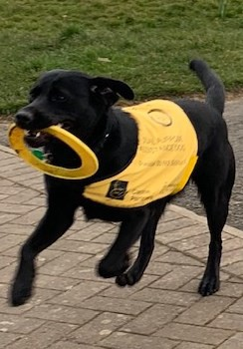

- Congratulations to Julie Cowie who has secured CSO funding
for a partnership project with disadvantaged communities to design and test a novel evidence-informed and community-based
intervention to address and promote healthy weight and wellbeing. This work involves researchers from across our two NMAHP-RU sites (Julie Cowie, Pat Hoddinott, Pauline Campbell, and Andy
Elders) and other expert collaborators from Stirling and
Aberdeen Universities, NHS Forth Valley and our 2 partnership communities.

Find us on the web! www.nmahp-ru.ac.uk @NMAHPRu

Contact NMAHP-RU

GCU
nmahpruadmin@gcu.ac.uk 0141 331 8100
Govan Mbeki Building, Glasgow Caledonian University, Cowcaddens Road, Glasgow, G4 0BA

Stirling
nmahp.ru@stir.ac.uk 01786 466341
Pathfoot Building, University of Stirling, Stirling, FK9 4LA
Recent publications
- Arensman, E., O'Connor, C., Leduc, C., Griffin, E., Cully, G., Ní Dhálaigh, D., Holland, C., Van Audenhove, C., Coppens, E., Tsantila, F., Ross, V., Aust, B., Pashoja, A., Cresswell-Smith, J., Cox, L., de Winter, L.,
Fanaj, N., Greiner, B., Hegerl, U., Mathieu, S., Moreno-Alcázar, A., Orchard, W., Paterson, C., Purebl, G., Qirjako, G., Reich, H. and Corcoran, P. (2022) Mental Health Promotion and Intervention in
Occupational Settings: Protocol for a Pilot Study of the MENTUPP Intervention. International Journal of Environmental Research and Public Health, 19 (2), pp. 947.
- Fenocchi, L., Collins, M., Elders, A. and Hagen, S. (2022) Assessment of the Relative Performance of the EQ-5D-3L, ICIQ-UI SF and POP-SS Using Data from the OPAL Trial. International Journal of Environmental Research and Public Health, 19 (3), pp. 1351.
- Fitzpatrick, D., Duncan, E., Moore, M., Best, C., Andreis, F., Esposito, M., Dobbie, R., Corfield, A. and Lowe, D. (2022) Epidemiology of emergency ambulance service calls related to COVID-19 in Scotland: a national record linkage study. Scandinavian Journal of Trauma, Resuscitation and Emergency Medicine, 30 (1), pp. 9.
- Whittaker, A., Elliott, L., Taylor, J., Dawe, S., Harnett, P., Stoddart, A., Littlewood, P., Robertson, R.,
Farquharson, B. and Strachan, H. (2022) The Parents under Pressure parenting programme for families with fathers receiving treatment for opioid dependence: the PuP4Dads feasibility study. Public Health Research, 10 (3).

Directors Blog:
At the time of writing this, many of us in the Unit are busy working on new proposals in our core areas of work such as mental health and pelvic health to name but a few. This is in addition to the £32 million of research we are already delivering through the 42 active projects we currently have in the Unit. While we are in a constant process of seeking funding and delivering on existing projects, we also have to demonstrate our outputs and impacts to funders and beyond. We are now entering the annual impact reporting process that is conducted through the Researchfish portal. This is used by a whole range of government, research council, and charitable
organisations to collect information to assess the impact of their research spending. It is a time-consuming and complex process for a Unit of our size (and for the majority of our 42 projects). Coupled with multiple submissions to other research impact assessment exercises, such as the Research Excellence Framework (REF), it seems like we also spend a great deal of time demonstrating the value of our work. However, our success is built on undertaking projects which are of significance and value to patients, healthcare
practitioners and the NHS. So we never feel we have a problem in demonstrating its impact
– just perhaps a lack of time to report it all!

Best Wishes, Margaret Maxwell

