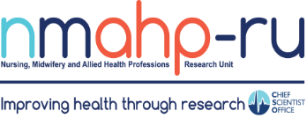
Newsletter
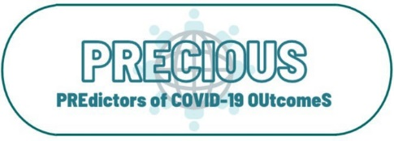
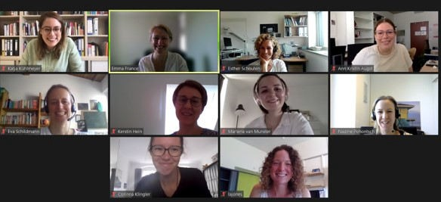

In brief:
- Prof Helen Cheyne

Volume 3, Issue 3. 31/07/21
PREdictors of COVID-19 OUtcomeS (PRECIOUS)

By Dr Myzoon Ali

and Dr Charlotte Paterson presented results of a qualitative evaluation of blood pressure home-monitoring for high-risk pregnant women in Scotland to the Scottish Perinatal Network.
- Good Luck to Dr Mayara Silveira Bianchim who is running the London Marathon for the Cystic Fibrosis Trust.
- Dr Fiona Harris was invited to contribute to a United Nations international expert panel to develop a risk profile of an emerging threat to human health in
More than 187 million people worldwide have had COVID-19. In the UK, more than 200,000 people have Long-COVID: when symptoms last more than 3 weeks. These numbers continue to grow. We urgently need information about the long-term effects of COVID-19 to provide better care, including identifying who needs support, what kind of support and how much it costs.
PRECIOUS will bring together international COVID-19 data to create a large database with information from thousands of people that have had
COVID-19. We will describe long-term effects, the predictors of recovery and the health, and social service support that people need.
Our team includes experts in IPD meta-analysis, systematic reviews, statistics, rehabilitation of long term conditions, health economics, care of the elderly, respiratory medicine, infectious diseases, immunology as well as experience of living with and caring for people with COVID-19.
Better understanding of long-term COVID-19 recovery and the people that experience poor recovery will help people with COVID-19 and healthcare staff understand and identify
problems earlier, organise suitable support, advice and treatment for those who need it most. At the end of the project, we will share our database with other researchers so that they can answer other COVID-19 questions.

Southeast Asia. Further information and the full report can be found here.

Meta-ethnography: sharing expertise internationally

By Associate Professor Emma France

Inside this issue:
PREdictors OF 1
Covid-19
OUtcomeS (PRECIOUS)
By Dr Myzoon Ali

Meta-ethnography: 1 sharing expertise internationally
By Associate Professor Emma France

Research 2
Partnership Group
member spotlight: A health professional perspective
By James Reid
Evidence-based healthcare
requires rigorous research evidence and evidence syntheses. Increasingly qualitative research is being synthesised to support practice and policy. Meta-ethnography is a way of pulling together evidence from multiple qualitative studies to develop new insights and conceptual understandings. Associate Professor Emma France, an expert in meta- ethnography, delivered three invited international workshops on meta- ethnography conduct and reporting in April and July 2021. One was for the Agency for Healthcare Research and Quality (AHRQ), USA - the lead Federal agency charged with improving the safety and quality of America's health care system.
Attendees included the
AHRQ Medical Officer and
members of its Scientific Resource Center as well as representatives from evidence-based practice centres in Kaiser Permanente, RAND, Mayo Clinic, and several high profile US universities such as Brown University and Johns Hopkins University. The second was organised by the University of Stavanger,
Norway, with 39
international post-graduate and academic attendees from Norway, Sweden, Finland, Denmark, Austria
and Syria, among other
countries. The University of Munich, Germany, hosted the third workshop for
health researchers across Germany.
Emma led the development of the eMERGe meta- ethnography reporting guidance (h ttps://
e mergeproject.org/) and is currently leading a meta- ethnography on the experiences and management of children’s chronic pain (h ttps://
f undingawards.nihr.ac.uk/ a ward/NIHR128671).

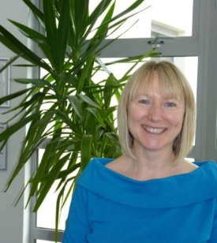

Research Partnership Group member spotlight: A health professional perspective

My name is James Reid and I am a speech and language therapist in NHS Forth Valley. I work in a learning disability team alongside other AHPs, nurses, doctors and social work colleagues. My weeks are diverse and usually include caseload work, training others in areas of communication and
swallowing, service development or quality improvement projects, personal development, and research related activities. At the moment I participate in several collaboratives producing new research and I also sit on NHS Forth Valley
Research and Development Committees at Board and AHP levels. As an AHP interested in research I joined the Research Partnership Group for various reasons. I wanted to support the group with an AHP voice and perspective, to offer professional opinions, to connect with others engaging in research activity, and last but not least learn more about research and PPI practices so that my involvement in future research would be more
valuable. I think there is an opportunity to improve research activities with more and better collaborations between research institutions and practising AHPs and I hope to be part of some of these in my own area of expertise. I look forward to working with you in the
future.

Find us on the web! www.nmahp-ru.ac.uk @NMAHPRu

Contact NMAHP-RU

GCU
nmahpruadmin@gcu.ac.uk 0141 331 8100
Govan Mbeki Building, Glasgow Caledonian University, Cowcaddens Road, Glasgow, G4 0BA

Stirling
nmahp.ru@stir.ac.uk 01786 466341
Pathfoot Building, University of Stirling, Stirling, FK9 4LA
Recent publications
  - Copeland, L., Littlecott, H., Couturiaux, D., Hoddinott, P., Segrott, J., Murphy, S., Moore, G. and Murphy, S.(2021) The what, why and when of adapting interventions for new contexts: A qualitative study of researchers, funders, journal editors and practitioners’ understandings. PLos One, 16(7), e0254020.
  - Frawley, H., Shelly, M., Morin, S., Bernard, K., Bo, A., Digesu, T., Dickinson, S., Goonewardene, S.,
McClurg, D., Rahnama’I, S., Schizas, A., Slieker-ten Hove, M., Takahashi, S. and Guevera, J. (2021) An International Continence Society (ICS) report on the terminology for pelvic floor muscle assessment.
Neurourology and Urodynamics, 40 (5), pp. 1217-1260
  - Hogg, B., Medina, J., Gardoki-Souto, I., Serbanescu, I., Moreno-Alcazar, A., Cerga-Pashoja, A., Coppens, E., Toth, M., Fanaj, N., Greiner, B., Holland, C., Kolves, K., Maxwell, M., Qirjako, G., de
Winter, L., Hegerl, U., Perez-Sola, V., Arensman, E. and Amann, B. (2021) Workplace interventions to reduce depression and anxiety in small and medium-sized enterprises: A systematic review. Journal of Affective Disorders, 290, pp. 378-386.

The full list of papers is available at https://www.nmahp-ru.ac.uk/research/publications/

Directors Blog:
In our last newsletter, I referred to new UK-wide vision for research in the NHS. There are two further key drivers, which will shape the type of research we do and the focus for research funding at national, European and international levels. The first of these is the UK Innovation Strategy, where innovation is seen as central to tackling the challenges the world faces, from climate change and the ageing society to global pandemics. The operationalising of this strategy will be conducted through the major funding
organisations of Innovate UK and UKRI, which is why we need to take note and understand how we can contribute to this new
agenda. The second is the ‘mission’ driven or ‘grand challenges’ approach which is currently at the centre of Horizon Europe and the UN’s Sustainable Development Goals. Although only one of the current five Horizon Europe missions is directly focused on health (Cancer), ‘health’ is still one of the six Global Challenges and European Industrial Competitiveness Clusters. We have always had a ‘problem’ based approach in the NMAHPRU, tackling health and healthcare delivery problems of significance to patients and the NHS. Tackling ‘missions’, ‘challenges’ and ‘problems’ are alternative ways of saying we want to make a significant difference to people’s lives. The NMAHPRU has always, and always will be, up to the challenge!
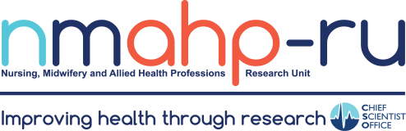
Best Wishes, Margaret Maxwell

