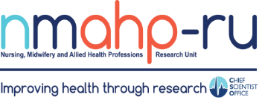
Newsletter: an international edition

Volume 1, Issue 4. 31/10/19
Co-developing interventions to reduce road traffic related trauma in Africa By Dr Edward Duncan
In brief:
- Well done to Prof Marian
Brady, who was presented with an RCSLT (Royal College of Speech & Language Therapists) fellowship by HRH The Countess of Wessex & RCSLT president Nick Hewer.
- The website of
the maternal mental health MAP study, co- conducted by the
NMAHP-RU and City, University of
London, is now live! https:// blogs.city.ac.uk/
map/ @themapstudy
- Kirsteen Goodman showcased a range of trial studies over
three days at the
ICTMC (International Clinical Trials Methodology Conference) in Brighton at the start of October.
- Kris McGill won the Verna Wright best Oral presentation 2019, and Kathryn
VandenBerg won the Verna Wright best poster prize 2019, from The Society for Research in
Rehabilitation.

Roads are dangerous, but many people are surprised when they find out just how deadly they are. Globally, as many as 1.4m people are killed every year – about one every 23 seconds – while another 20m to 50m are injured but survive,
often with life-changing disabilities. These statistics make road traffic collisions currently the eighth biggest killer in the world.
Shockingly, over 90% of
these deaths occur in low
and middle income countries, where the death rate from road traffic collision continues to rise.

Building on over 10 years of developing and evaluating complex pre-hospital emergency care interventions and systems in the Global North, the NMAHP Research Unit is currently leading an interdisciplinary group to
tackle road traffic related
trauma in the Global South. Our Safe Roads Africa partnership includes clinicians, academics, NGOs, and community workers from Scotland, Malawi and Zambia. Our original Global Challenge Research Fund Medical Research Council
and Arts and Humanities Research Council award led to the development of a community first responder champion intervention and the development and feasibility testing of an
adolescent-focused public health intervention to prevent road traffic collisions. These projects have been developed with key partners and local communities in Southern Malawi and Zambia.
Future studies will evaluate the impact of
these interventions and, if effective, create resources for their implementation across sub-Saharan Africa and beyond.

Maternal mental health collaborations in Malaysia By Dr Fiona Harris

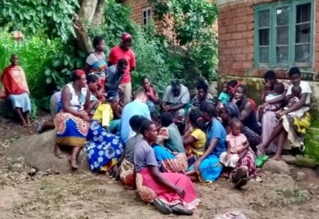
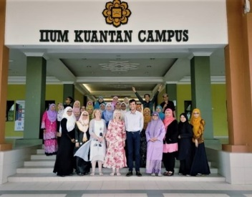
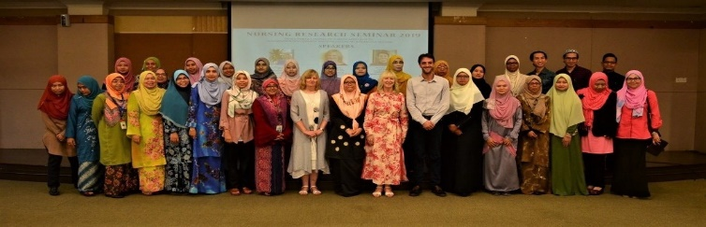
In the NMAHP Research Unit, research capacity building, career development and the
strategy of building on exploratory work to
ultimately develop
sustainable interventions are at the heart of what we do. Our recent research networking trip to Malaysia was a good example of
Inside this issue:
this. Drawing on our expertise in mental health and maternal health research, two NMAHP Research Unit PhD
1
RTA
interventions in Africa
Maternal
Mental Health in Malaysia
students supervised by Helen Cheyne and Margaret Maxwell were involved in the development of a pan- Southeast Asian network in perinatal mental health.
2
Pelvic Floor Research in the Pacific Islands
1
Helen, Margaret and Fiona Harris secured Connect+ funding from the University of Stirling to support a trip

to Malaysia in July to facilitate two workshops: one in Kuala Lumpur to develop our research collaboration and another in Kuantan to deliver a
theory of change workshop with staff and students at
the International Islamic University of Malaysia.
Margaret and Fiona were joined by PhD student Andrea Sinesi who presented his work on screening for antenatal anxiety and former student, Dr Siti Roshaidai who presented results from her research on postnatal depression in Malaysia.
Our participatory workshop with colleagues from Malaysia, Myanmar, Thailand and Indonesia resulted in some exciting and innovative research plans that we are taking forward in project grant proposals.

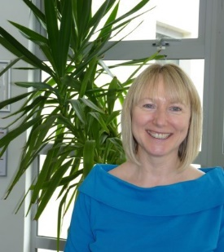
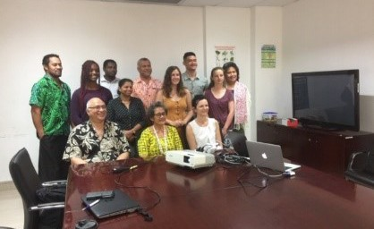

Pacific Islands Pelvic Health Research Partnership By Prof Suzanne Hagen

Suzanne Hagen received funding from the GCU Global Challenges and Sustainable Development Unit to travel to the Pacific Islands to establish collaborations and develop a network of individuals with a shared interest in pelvic health research. From 26 May to 7 June, she had meetings in
Samoa, Fiji, and Tonga with potential clinical and academic
collaborators, presented seminars, and contributed to research workshops.
Partnerships were established with the National University of
Samoa’s Faculty of Health Science members, in particular with clinical staff involved in teaching nurses and with the Research
Ethics Committee.
Partnerships were also established with staff at Fiji National University, including the Vice Chancellor, Pro-VC Research and Pro-VC Learning & Teaching, and
local clinical staff in the main hospitals in Suva, Nadi, and Labasa. Similarly, we established collaborations with senior clinical staff in Tonga, advisors for the Ministry of Health, and senior staff members at the Nursing School. As a result, we are now working with our Pacific Island collaborators to develop two seed funding grants to prepare for a future large-scale grant application for GCRF funds.

Recent publications

Find us on the web! www.nmahp-ru.ac.uk @NMAHPRu

Contact NMAHP-RU

GCU
nmahpruadmin@gcu.ac.uk 0141 331 8100
Govan Mbeki Building, Glasgow Caledonian University, Cowcaddens Road, Glasgow, G4 0BA

Stirling
nmahp.ru@stir.ac.uk 01786 466341
Unit 13 Scion House, University of
Stirling Innovation Park, Stirling, FK9 4NF

Brittenden, J., Cotton, S., Cooper, D., Dimitrova, M., Scotland, G., Elders, A., MacLennan, G., Ramsay, C., Norrie, J., Burr, J., Campbell, B., Bachoo, P., Chetter, I., Gough, M., Earnshaw, J., Lees, T., Scott, J., Baker, S., Tassie, E., Francis, J. and Campbell, M. (2019) Five-Year Outcomes of a Randomized Trial of Treatments for Varicose Veins. New England Journal of Medicine, 381 (10), pp. 912-922. ● Bunce, C., Stratton, I., Elders, A., Czanner, G., Doré, C. and Freemantle, N. (2019)
Ophthalmic Statistics Note 13: Method agreement studies in ophthalmology – please don’t carry on correlating. British Journal of Ophthalmology, 103 (9), pp. 1201-1203. ● McDicken, J., Blayney, G., Elliot, E., Makin, S., Ali, M., Larner, A., Quinn, T. and on behalf of the VISTA-Cognition Collaborators. (2019) Accuracy of the Short Form Montreal Cognitive Assessment – Systematic Review and Validation. International Journal of Geriatric Psychiatry, 34 (10), pp. 1515-1525. ● O'Cathain, A.,
Croot, L., Duncan, E., Rousseau, N., Sworn, K., Turner, K., Yardley, L. and Hoddinott, P. (2019) Guidance on how to develop complex interventions to improve health and healthcare. BMJ Open, 9 (8), pp. e029954. ● Pollock, A., Campbell, P., Struthers,
C., Synnot, A., Nunn, J., Hill, S., Goodare, H., Morris, J., Watts, C. and Morley, R. (2019) Development of the ACTIVE
framework to describe stakeholder involvement in systematic reviews. Journal of Health Service Research & Practice, 24 (4), pp. 245-255. ● Rowe, F., Hepworth, L., Conroy, E., Bacon, N., Bedson, E., Drummond, A., Garcia-Finana, M., Howard, C., Pollock, A., Shipman, T., Dodridge, C., Johnson, S., Noonan, C. and Sackley, C. (2019) Visual Function Questionnaire as an outcome measure for homonymous hemianopia: subscales and supplementary questions, analysis from the VISION trial. Eye, 33 (9), pp. 1485-1493.

The full list of papers is available at: https://www.nmahp-ru.ac.uk/research/publications/

Directors Blog:
In this edition, we showcase a variety of our current international collaborations which address global health challenges and at the same time promote knowledge exchange, methodological innovation and capacity building in low and middle income countries.
We also celebrate Prof. Marian Brady’s award as a Fellow of the Royal College of Speech and Language Therapy. The NMAHP Research Unit can take some credit in this award, having provided a unique and stable environment within which
NMAHPs can develop the skills and experience to become world class, internationally and professionally recognised experts in their field. Marian has been with the NMAHP Research Unit since 2000. This award adds to previous accolades such as: the international Robin Tavistock Award (2016) for her contributions to aphasia research; Honorary Life membership of the Stroke Society for Australia (2015); and an Honorary Chair at the University of Queensland, Australia. This is just one example from the Unit, which reflects the recognition of our NMAHP research on the national and international stage.

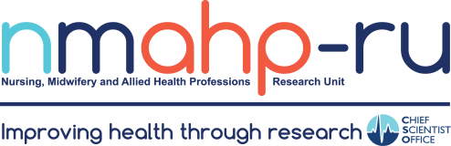
Best Wishes, Margaret Maxwell

