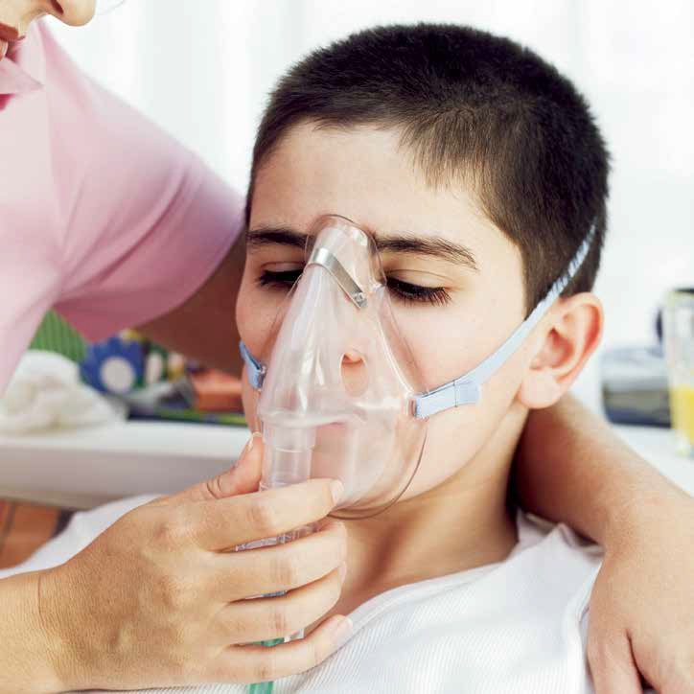
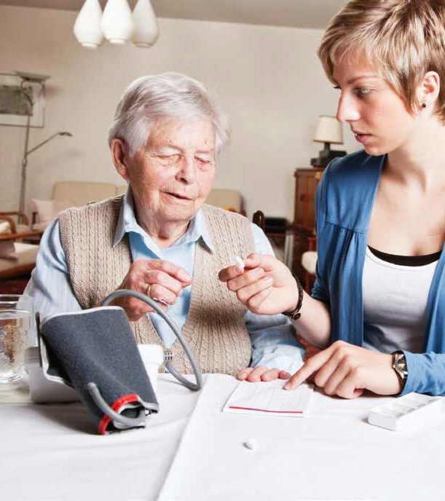
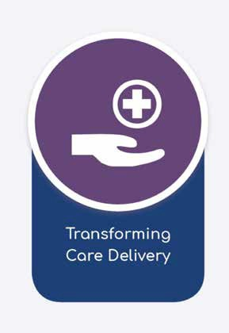
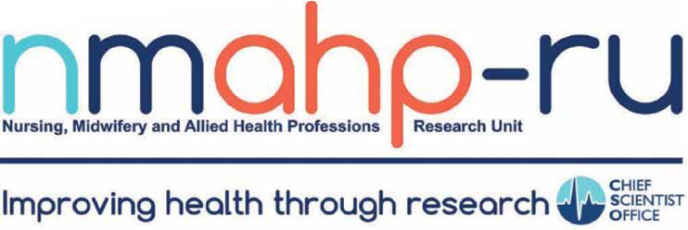
Transforming Care Delivery
Nursing, Midwifery and Allied Health Professions Research Unit

This programme places people and their healthcare journeys at the heart of understanding quality and delivery of care. It aims to understand; how health and social care systems of care adapt, interface and integrate with each other over time; how different systems operate to deliver seamless and comprehensive care and to explore the changing roles of healthcare professionals and use of others in delivering innovative new ways of working.

The programme includes implementation science methods to provide robust research evidence of which strategies work to facilitate implementation of evidence based healthcare in a safe, effective way and sustainable way, reaching the intended target audience and maintaining the outcomes demonstrated in controlled trials.

The focus of the programme is guided by key current changes to healthcare: health and social care integration; the need for more care to be delivered at or closer to home; the crucial role that primary care will play in future delivery; changing roles of healthcare professionals, involvement of 3rd and voluntary sectors and non-professional care staff.

Strategic aims:
- To work with and enable NHS staff, policy makers, patients and the public to identify effective
and sustainable policies and interventions to impact on health and social care
- To respond to increasing needs of practitioners, policy makers, patients and the public for robust timely and useful evidence of what works to improve the health and wellbeing of the people of Scotland and beyond.

Involving people and practitioners in research:
The Unit has established a Research Partnership Group to ensure that the vision and objectives of the Unit are achieved in an optimal way and that outputs are relevant and valuable to patients, the public and health and social care workers. The RPG inputs significantly to this programme and others within the Unit.

See inside pages for study examples.

Safety
SAS COPD study
Evidence suggests that patients with Chronic Obstructive Pulmonary Disease (COPD) are still receiving higher than required levels of oxygen in the pre- hospital phase of their treatment and that this is having a detrimental effect on ongoing care.
A retrospective linked data study of ambulance service and patient mortality and morbidity data is currently being undertaken. The study aims to determine pre- hospital and emergency department treatment patterns of oxygen therapy and the short-term patient outcome.
Follow-up hypoglycaemic emergencies
Follow-up hypoglycaemic emergencies: Patients, with certain conditions, who are attended by ambulance services are increasingly being treated and left at home, instead of being routinely transported to hospital. Research has shown that patients who are treated for hypoglycaemic emergencies and left at home do not always follow up their care. This project developed and piloted a dual intervention to encourage and support patients to follow-up their care: a patient prompt card that was left with patients; and a follow-up telephone call from NHS24. Further studies are now planned to test the effectiveness of this intervention.
Safe Roads Africa
Road traffic collisions are a major cause of preventable death in Sub-Saharan Africa. There is a crucial need to improve prevention and first-response interventions within local communities affected by road traffic-related trauma. Our Medical Research Council and Arts and Humanities Research Council Global Health research award aims to 1) build research partnerships; 2) work with local communities to understand their perspectives in the factors that lead to road traffic related trauma; and 3) develop a “Community Resilience Intervention” protocol. This work will form the basis for future research.
Models of Care Delivery
Postnatal Care Resource Allocation Model (PRAM)
The project uses computer based service re-design methods to assist development of effective and efficient models of postnatal care tailored to local needs. Computer- based modelling makes cost and quality implications of design options explicit informing the redesign process. PRAM engages stakeholders in debate about their values and priorities for service allocation and the trade-offs required between cost and quality to match services to budgets.
Preventing and Improving Awareness across the EU (PREDI-NU) This project involved the development of an internet-based guided self-management tool for mild to moderate depression: an evidence based approach. Translated for 11 European languages.
www.ifightdepression.com
Patient Centred Outcomes and Patient Experience
The Scottish Person Centred Interventions Collaboration (ScoPIC) Government funded collaboration between universities in Scotland and several NHS boards. Its core aims are: the evaluation of NHS national and local initiatives aimed at improving patient experience of care; improving the understanding of the causes and consequences of good and poor patient experience of care; and developing effective research and audit tools for the evaluation of patient experience of person centred care. www.nmahp-ru.ac.uk/scopic
Perinatal Mental Health
This study aimed to develop and test a questionnaire to screen for anxiety in pregnancy. During pregnancy, around one in seven women develop significant clinical anxiety that can have a negative effect on long-term health and wellbeing of mothers and babies. Yet there are currently no reliable screening tools to distinguish between significant clinical anxiety and the normal anxieties and worries women may experience during pregnancy. The project involved women with experience of poor perinatal mental health and health professionals in supporting the development of this new screening scale.
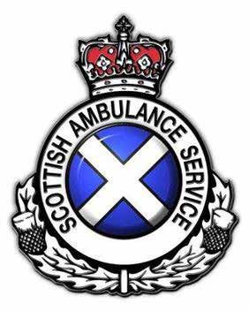
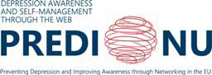

G-AP: Development and initial evaluation of a Goal setting and Action Planning (G-AP) framework for use in community based stroke rehabilitation
Goal setting is considered ‘best practice’ in stroke rehabilitation. However, there is no consensus about the key components of goal setting interventions, how they should be optimally delivered in practice and how best to involve stroke survivors and carers in the process. This programme of work describes the development and initial evaluation of a theory-based Goal setting and Action Planning (G-AP) framework to guide person centred goal setting practice in community based stroke rehabilitation settings.
Effectiveness and Assessment of Care Quality
Patient Centred Assessment Method (PCAM)
Developed in partnership with University of Minnesota this is a practical tool for nurses conducting health checks to holistically assess mental wellbeing and biopsychosocial needs of patients in a manner which facilitates the referral and sign-posting to appropriate medical, psychological, social and lifestyle/self-help services.
I-PRAISE
People with aphasia have difficulty speaking, understanding speech, reading & writing. There are many unanswered questions about aphasia recovery, the best treatments, timing of treatments, & the role of support services in recovery from aphasia. Although research is carried out in clinical trials, information from trials is not as informative for the clinical population as trial participants typically differ from people who are seen in hospitals. I-PRAISE is an international project that aims to collect information on people with aphasia after stroke, who present at a hospital or clinic across different participating countries. It is open to anyone with aphasia due to stroke and the information collected will help us to examine recovery in the general population, describe what therapies and resources are available and how we can learn from the practices and treatments available in different countries to improve care for aphasia.
Implementation Science
Implementation science (also known as improvement science) is a field of study that seeks to provide robust evidence of which strategies work best to facilitate wide scale, sustained, evidence based healthcare in a safe and effective way. The Unit has recognized expertise in Implementation Science, in particular using realist and other theory informed approaches. We work closely with NHS staff and policy makers to facilitate implementation of evidence based interventions in key areas of healthcare priority and to develop and refine methods and theories to contribute to the growing implementation/improvement science knowledge base.
Prolapse and Pelvic Floor Muscle Training (PFMT): Implementing Evidence Locally (PROPEL study)
Despite good evidence that PFMT reduces symptoms of pelvic organ prolapse and improves quality of life for women, there is wide variation in its provision across the UK, namely due to limited numbers of specialist physiotherapists who can deliver PFMT. This project aims to study implementation and outcomes of different models of delivery to increase service provision of PFMT across contrasting NHS sites.
Distress Brief Intervention Evaluation
The need to improve the response to people presenting in distress has been strongly advocated by people who have experience of distress, by front line service providers, and is supported through a review of available literature.The Distress Brief Intervention approach was funded as a result from the Scottish Government’s work on the Suicide Prevention and Mental Health strategies. We are leading the evaluation of this study in collaboration with ScotCen, The Mental Health Foundation and Glasgow Caledonian University.
Advance Nurse Practitioner (ANP)
Advance Nurse Practitioner (ANP) roles are being implemented to address the pressure on primary care services, however, little is known about ANP implementation in primary care across the UK. The aim of this case study was to examine the implementation of ANP roles in primary care across Scotland, to determine what works, for whom, why and in what circumstances. A realistic evaluation was conducted using a multiple case study approach, semi-structured interviews with key informants across 15 health boards in Scotland, and documentation analyses. A qualitative descriptive approach and framework analysis was used to analyse data. Results indicate that ANPs have capabilities to take on elements of the GPs role whilst ANP role implementation requires: leadership, collaboration and engagement of key stakeholders to deliver a structured competency based academic and work based education programme. However, resources and capacity to train ANPs were a challenge in a service that was already under pressure.
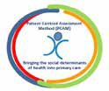

Twitter: @nmahpru
nmahpruadmin@gcu.ac.uk
nmahp.ru@stir.ac.uk
0141 331 8100
01786 466341
Contact details:
General contact Stirling: General contact GCU:
Pathfoot Building 6th floor Govan Mbeki Building University of Stirling Glasgow Caledonian University Stirling Cowcaddens Road
FK9 4LA Glasgow
G4 0BA
www.nmahp-ru.ac.uk

Selected publications in transforming care delivery:
- Bowers J, Cheyne H, Mould G, Miller M, Page M, Harris F, Bick D. (2018) A multicriteria resource allocation model for the
redesign of services following birth. BMC Health Services Research 18:656. https://doi.org/10.1186/s12913-018-3430-1
- Brady, M. and Evans, J. (2018 (In Press) Language and Cognitive Rehabilitation. In: J. Saver and G. Hankey, eds. Stroke Treatment and Prevention. Cambridge University Press.
- Cowie, J. and Burstein, F. (2018) A decision support tool for supporting individuals with long-term conditions make informed choices: LTC-Choices tool for continuous healthcare. Journal of Decision Systems, 27 (Suppl 1), pp. 123-131. Doi: https://doi.org/10.1080/12460125.2018.1460157
- McClurg, D., Bugge, C., Elders, A., et al. (2018) Factors affecting continuation of clean intermittent catheterisation in people with multiple sclerosis: Results of the COSMOS mixed-methods study. Multiple Sclerosis (e-Pub Ahead of Print) Doi: https://doi.org/10.1177/1352458518768722
- Sinesi, A., Maxwell, M., O’Carroll, R., & Cheyne, H. (2019). Anxiety scales used in pregnancy: systematic review. BJPsych
Open, 5(1), 1-13. Doi: https://doi.org/10.1192/bjo.2018.75

Unit background:
The Nursing, Midwifery and Allied Health Professions Research Unit (NMAHP RU) is a multidisciplinary national research unit, funded by the Scottish Government Health Directorate Chief Scientist Office. It has academic bases within Glasgow Caledonian University and the University of Stirling.

Research programmes:
NMAHP RU focuses its activity on three strong programmes of research that will impact on NMAHP practice and benefit patient and population health. These are: Innovation in NMAHP Interventions, Transforming Care Delivery and Maximising Data Usage in NMAHP Research. This leaflet provides information on the Transforming Care Delivery Programme, led by Professor Helen Cheyne.

Find out more:
You can find further information on all of our research programmes, recent research projects, publications
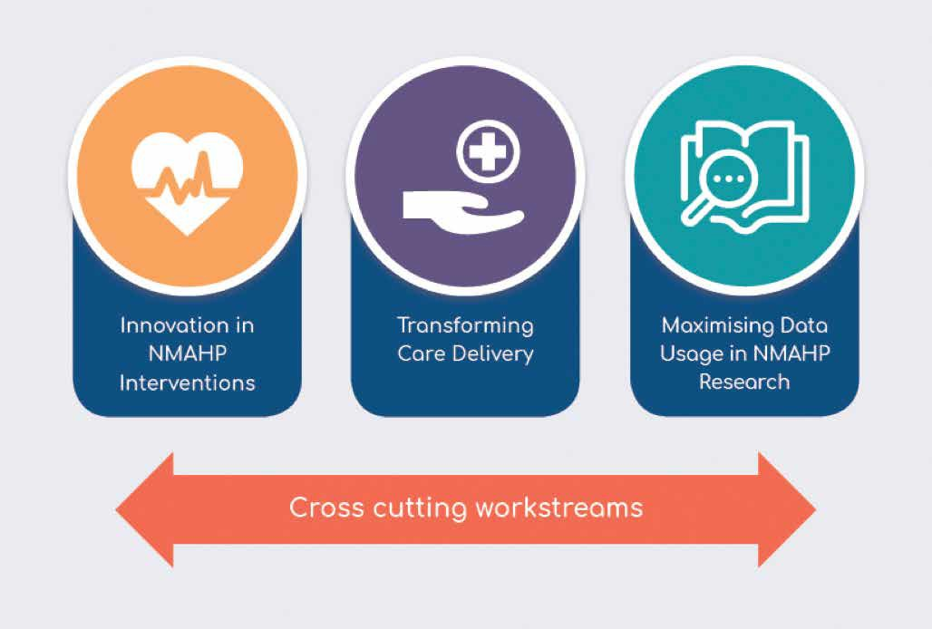
and keep up to date with our latest news, on our website: www.nmahp-ru.ac.uk

