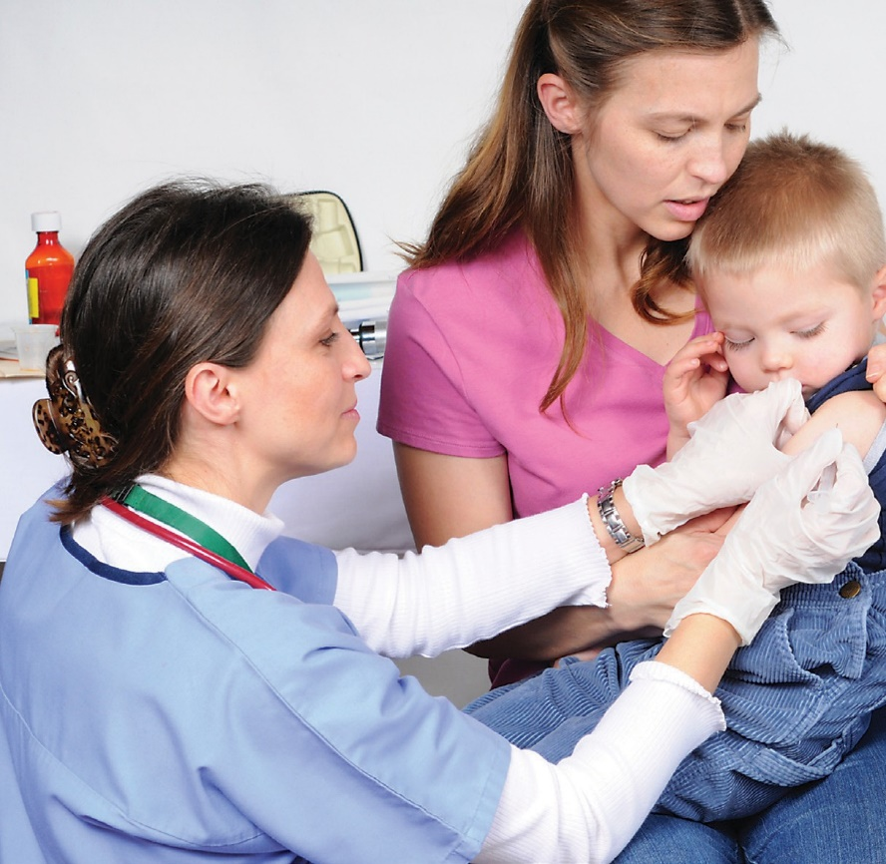
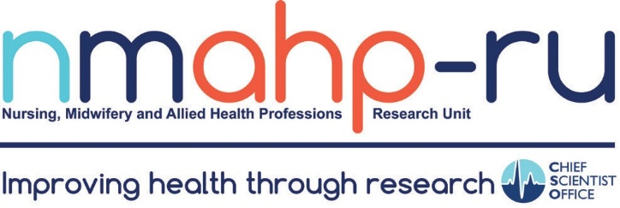
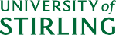

Find out more:
The Unit has a website: www.nmahp-ru.ac.uk
Here you can find details on all our recent research projects and publications and keep up to date with our regular news feeds.

Further websites support the dissemination of specific
projects:

Database of Research in Stroke (DORIS):

www.askdoris.org

Framework for Measuring Impact is a decision making framework designed to help allied health professionals select and use appropriate outcome measures: www.measuringimpact.org

Person Centre Assessment Method (PCAM):

www.pcamonline.org
Contact details:
General contact Stirling:
Pathfoot Building
University of Stirling
Stirling
FK9 4LA

01786 466341

nmahp.ru@stir.ac.uk

General contact GCU:
6th Floor Govan Mbeki Building Glasgow Caledonian University Cowcaddens Road
Glasgow G4 0BA

0141 331 8100

nmahpruadmin@gcu.ac.uk

Twitter: @nmahpru
Nursing, Midwifery & Allied Health Professions Research Unit
www.nmahp-ru.ac.uk

Unit background:
The Nursing, Midwifery and Allied Health Professions Research Unit (NMAHP RU) is a multidisciplinary national research unit, funded by the Scottish Government Health Directorate Chief Scientist Office (CSO). It has academic bases within Glasgow Caledonian University and the University of Stirling.

Vision and objectives:
- To conduct high quality applied research that enables nurses, midwives and allied health professionals to make a difference to the lives of the people of Scotland and beyond.
- To work with and enable the NHS and policy makers to identify effective and sustainable policies and interventions to impact on health and social care.
- To be an internationally renowned and innovative centre of excellence for NMAHP Health and Social Care research.
- To maintain a highly supportive multidisciplinary environment and expand research capacity and capability across the professions to deliver the NMAHP researchers and research leaders of tomorrow.

Working with others:
We work collaboratively with the public, patients and their carers, academic and clinical colleagues across Scotland and internationally to enable us to optimise the valuable outputs we produce.

The Unit is committed to engaging and re-engaging practitioners in research to improve and develop Scotland’s Nursing, Midwifery and Allied Health Professional research capacity. We do this through supporting PhD studentship and post-doctoral research fellowship applications, and other funded initiatives open to NMAHP researchers.

We work closely with the health service, service users/patients and policy makers to improve the evidence base for interventions in NMAHP practice and the quality of care that NMAHPs deliver.

Research programmes:

Innovation in NMAHP Interventions:
To develop the evidence base for NMAHP care on two fronts: NMAHP delivered Healthy Living Interventions, and NMAHP Therapeutic Interventions. This reflects the priorities for health and social care delivery and population health, in particular, the need to provide effective and cost effective health and social care, prevent illness and promote healthy behaviours. The Unit will continue to use its expertise in developing innovative IT (e-health) solutions in both the health promotion and therapeutic fields of NMAHP research.

Transforming Care Delivery:
This programme places people and their healthcare journeys at the heart of understanding quality and delivery of care. It aims to understand; how health and social care systems of care adapt, interface and integrate with each other over time; how different systems operate to deliver seamless and comprehensive care for patients and to explore the changing roles of healthcare professionals and use of non-professionals in delivering innovative new ways of working.

Maximising Data Usage in NMAHP Research:
To reduce research waste and enhance efficiency; to respond to the needs of the NHS with more timely production of research; to develop researchers with the necessary skills to further NMAHP research using large/linked datasets.
These programmes of research enable the Unit to respond to and address a wide range of healthcare and clinical problems. This also involves understanding the behavioural (patient and practitioner) and organisational (system) influences on intervention development and up-take to enhance the implementation and translation of evidence based solutions into practice.

Although the Unit addresses many clinical areas much of our work is currently focused on stroke, pelvic health, maternal and child health, long term conditions (including mental health), population health, and innovation in systems, services and roles.

Our skills:
The NMAHP RU is a multi-disciplinary research unit comprising over 60 academics, researchers and support staff. This includes Nurses, Midwives and Allied Health Professionals including occupational therapy, prosthetics, physiotherapy, optometry, and speech and language therapy. In the social sciences we currently have sociologists, psychologists, and anthropologists. We also have statisticians contributing to our work in intervention trials and data linkage/ epidemiological work, along with high level qualitative skill sets and systematic reviewers.

We have 7 Professorial research leads covering Nursing, Midwifery, AHPs and Primary Care.

The Unit has developed a critical mass of NMAHP Trialists to support methodological developments in randomised controlled trials, including economic evaluation, of complex interventions relevant to the nursing, midwifery or allied health professions. Our trials are supported by the:

- Trial Management Group: consists of highly experienced trial managers and researchers
- Quantitative Methods Group: consists of experienced statisticians and data analysts
- Qualitative Trialists: researchers who use their qualitative skills to support the development of interventions; understanding of trial implementation; and understanding of trial outcomes.

The Unit has experts in Implementation Science to provide robust research evidence of which strategies work to facilitate implementation of evidence based healthcare in a safe and effective way, reaching the intended target audience and maintaining the outcomes demonstrated in controlled trials.

The Unit also has expertise in using existing datasets and linked datasets and the methodological and statistical skills required for the analysis of large scale datasets used in epidemiological studies and studies to explore variation in healthcare and treatment outcomes, patient pathways, and long term outcomes for trials.

