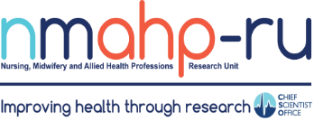
Newsletter
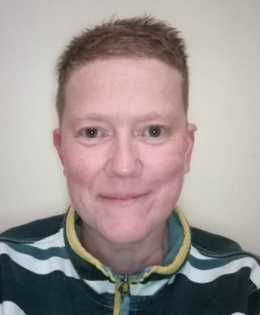

In brief:
- Congratulations to Christine Hazelton who has been awarded the UK
Volume 5, Issue 1. 31/01/23

Patient and Public Involvement (PPI) PhD By Jay Webster

Stroke Forum’s Patient, Carer and Public Involvement Prize.
- Trial Successes: CaDeTs first Scottish Hub site
(NHS Lanarkshire) has opened to recruitment this month and we are in the process of setting up our second site (NHS Fife).
AMID is opening up South Lanarkshire as a PIC and they have had three referrals within the first 3 weeks. Recruitment will run until beginning of May this year.
I am delighted to be able to contribute to this NMAHP-RU newsletter as a relatively new PhD student currently undertaking research into public involvement in health and care research. It's been a whirlwind since I started in October 2022 but a really exciting one. I have met with many people and am learning so much every day. To be able to devote my
time to exploring the use
of public involvement in health and care research is phenomenal. I am
thrilled to be working on this project.
I have the privilege of being able to work with public contributors from all walks of life and have a number of people already getting involved in the work.

UK Stroke Forum (UKSF 2022)

By Dr Christine Hazelton

Working with the public is a great opportunity and I think that they have so much to offer.
I hope to link in with the NMAHP-RU research partnership group as well and am working with some members of this group for my cross-
sectional study at present.

If you would like to discuss anything to do with public involvement in health and care research, please feel free to get in
touch and we can have a chat.
jay.webster@gcu.ac.uk
TOPSY 4 year
follow-up has 191 women recruited

and questionnaire returns are currently high at 93%.

Inside this issue:
Leading researchers from NMAHP Research Unit played key roles in this year’s UK Stroke
PPI PhD  By Jay Webster | 1
UKSF 2022  By Christine Hazelton | 1
CATs are celebrating 10 years!  By Jaclyn McArthur | 2

Forum (UKSF 2022) in Liverpool from 29 November – 1 December.
They shared their expertise and world- leading research at the UK's largest
multidisciplinary conference for stroke care professionals, researchers and people affected by
stroke.
Dr Christine Hazelton, a Non-Clinical Stroke Association Lecturer, won the UKSF Patient, Carer and Public Involvement Prize for her work on the PIONEER project, exploring effective interventions for disorders
of perception after stroke. She presented her findings at the conference. Professor Marian Brady and Dr Lesley Scobbie showcased three research papers which have changed the lives of people with aphasia – a neurologically-based language impairment which affects the ability to speak and understand language. External
experts voted their research papers as three of the top scoring
abstracts across submissions to the 2022 conference and GCU was the only institution with more than one abstract selected in that category. Professor Brady leads the Nursing, Midwifery and
Allied Health Professions Research Unit (NMAHP) Stroke Rehabilitation Research programme and is founder of the Collaboration of Aphasia Trialists (CATs) network. Dr Scobbie, presented work on behalf of Dr Eleanor Brown, a former GCU PhD researcher, is a Stroke Association Clinical Lecturer and Scotland's first Allied Health Professions (AHPs) Stroke Clinical Academic with NHS Lanarkshire. She also presented on the challenges of setting and pursuing stroke
rehabilitation goals.

CATs are celebrating 10 years!

- Lynne Gilmour and Louise Honeybul are involved in an exciting partnership project with Children in Scotland and Scottish Ensemble about live music and how it can support young people’s mental health and wellbeing. Over the next six months they will be hosting workshops in
Stirling, Inverness and
Glasgow, with children and young people, musicians, live music event organisers and mental health
practitioners to develop innovative ideas for live music interventions.
For more information please contact: Dr Lynne Gilmour (Lyg1@stir.ac.uk) or
Louise Honeybul
(Louise.honeybul@stir.ac.uk)

Find us on the web! www.nmahp-ru.ac.uk @NMAHPRu

Contact NMAHP-RU

GCU
nmahpruadmin@gcu.ac.uk 0141 331 8100
Govan Mbeki Building, Glasgow Caledonian University, Cowcaddens Road, Glasgow, G4 0BA

Stirling
nmahp.ru@stir.ac.uk 01786 466341
Pathfoot Building, University of Stirling, Stirling, FK9 4LA
By Jaclyn McArthur

In 2023 we celebrate 10
years of The Collaboration of Aphasia Trialists (CATs). We will soon be hosting a number of exciting activities and events to reflect on all of our fantastic achievements.
CATs aims to improve the quality, relevance, reliability, validity, and transparency of aphasia research. We
strive to co-ordinate international aphasia research effort and activities; we share
multidisciplinary and patient
expertise, augmenting aphasia insights from all perspectives; we enhance the methodological rigour and clinical impact of aphasia trials proposals, protocols, assessments, intervention descriptions, conduct, reporting and dissemination; we
establish international, multidisciplinary, consensus on the highest quality aphasia research practices (priorities, core outcomes and participant descriptors, intervention
description) which in turn improves the relevance, value and credibility of aphasia research, maximising its contribution to the evidence base and impact on international aphasia treatment guidelines and policies.

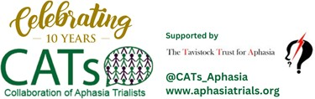
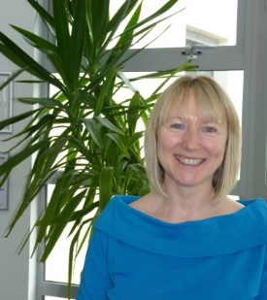

Recent publications
- Farquharson, B., Dixon, D., Williams, B., Torrens, C., McDermott, S., Laidlaw, H. and Philpott, M. (2023) The Psychological and behavioural factors associated with laypeople initiating CPR for out-of-hospital cardia arrest: A systematic review. BMC Cardiovascular Disorders, 23 (1), pp. 19.
- Johnston, W., Ware, A., Kuiters, W., Brown, J., Hagen, S., Corcoran, D., Cummings, M., Ramage, G. and Kean, R. (2023) In vitro bacterial vaginosis biofilm community manipulation using endolysin therapy. Biofilm (e-Pub Ahead of Print) Doi: 10.1016/j.Bioflm.2022.100101.
- Greiner, B., Leduc, C., O'Connor, C., Cresswell-Smith, J., Rugulies, R., Wahlbeck, K., Abula, K., Amann, B., Pashoja, A., Coppens, E., Maxwell, M., Corcoran, P., Ross, V., de Winter, L., Arensman, E. and Aust, B. (2022) The effectiveness of organisational-level workplace mental health interventions on mental health and wellbeing in construction workers: a systematic review and recommended research agenda. PLoS One, 17 (11), pp. e0277114.
- Malcolm, C., King, E., France, E., Kyle, R., Kumar, S., Dick, S., Wilson, P., Aucott, L., Turner, S. and
Hoddinott, P. (2022) Short stay hospital admissions for an acutely unwell child: a qualitative study of
outcomes that matter to parents and professionals. Plos One, 17 (12), pp. e0278777.
- Wallace, S., Worrall, L., Rose, T., Alyahya, R., Babbitt, E., Beeke, S., de Beer, C., Bose, A., Bowen, A., Brady, M., et al (2022) Measuring communication as a core outcome in aphasia trials: Results of the ROMA
-2 international core outcome set development meeting. International Journal of Language and Communication Disorders (e-Pub Ahead of Print) Doi: 10.1111/1460-6984.12840.

Directors Blog:
We start the new year with the nation facing many strikes, including those involving different NHS professionals, and all at a time when
demand for NHS services is ever increasing. It is without doubt that we need to value the staff working in the NHS and to give support to their careers. We also need to know that the NHS is delivering on efficient, safe, and effective care. This is where the clinical academic NMAHP
can make a big difference. However, we are lagging behind in Scotland in our support of NMAHP clinical academics. A recent paper on National Provision of Clinical Academic Training Awards for NMAHPs, Pharmacists, Psychologists, Healthcare Scientists and
Paramedics, on behalf of our Chief Nursing Officer for Scotland, showed the stark reality that investment for clinical academic training in Scotland was the lowest of all UK regions, with
England showing more than 5 times the investment. This means we miss out on research which can make a difference to direct patient care, but we may also be missing out on additional investment for NMAHP research in Scotland. Fewer clinical academics means research outputs and impacts within our HEIs are also lower, with the resultant loss of
potential REF income to Scottish institutions. Before our next newsletter the NMAHP-RU will have entered its final year of core funding from the Chief Scientist Office –alone this is a heavy blow for NMAHP research in Scotland. Our host HEIs will do their best to maintain the expertise we have built up over the past near 30 years, and we hope our strong
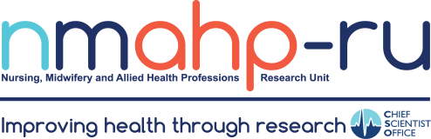
workstreams in important clinical areas will still attract research funding. However, now is the time for more investment in NMAHP research and careers in Scotland, not less.

Best Wishes, Margaret Maxwell

