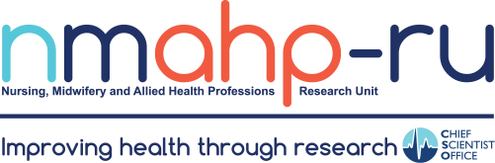
Newsletter

Volume 1, Issue 1 31/01/19
In brief:
- Dr Emma France and many co- authors celebrate the publication of the guidelines for reporting meta- ethnography.
- Dr Edward Duncan and colleagues are returning to Malawi in February to continue development of a community
resilience intervention to
reduce road traffic related trauma in sub-Saharan
Africa.
- The OPAL
randomised controlled trial which involved 600 women with urinary
incontinence from across the UK was completed in December 2018; a final report was submitted to the funders (NIHR HTA) and publications are in preparation.

Smoke Out by Dr Catherine Best et al.
In 1950 80% of the adult men in the UK smoked and advertising campaigns
featured health
professionals endorsing
tobacco consumption. Sixty years later tobacco is known to be the number one cause of preventable mortality.
Only 15% of adults in the UK now smoke and most of
them say they would like to

quit. Surely now the public is fully aware of the harms we can relax and let time take
its course? In fact no, our CRUK funded research on smoking prevalence in the European Union suggests
that only countries that take a comprehensive policy approach to tackling smoking see ongoing declines in smoking prevalence. We examined
tobacco control policy scale scores and smoking prevalence over time (2009- 2017) in 28 EU member
states. We used a three level mixed effects model to enable us to examine the
effects of tobacco policy while controlling for the country-level trajectories of smoking prevalence over
time. This analysis revealed that countries that did not have strong tobacco policies had smoking rates that remained stable over time (see graph).
In addition, we found that tobacco policy has
significantly more impact on people who are
economically active than
those who are not. That is, the economically inactive such those who are retired, students or who work in the
home are largely unaffected by the extent of national
tobacco policies. This ties in with other research that has found that those with lower levels of education are similarly less affected and more targeted intervention may be required to reduce
the high smoking rates in these groups.

Inside a trial Dr Fiona Harris presenting innovations in clinical trials at the International Qualitative Health Research Conference in Halifax
Inside this issue:

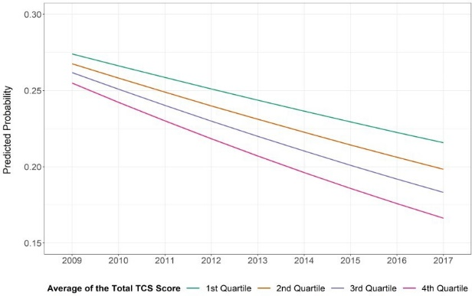
Smoke Out
1

Inside a trial
1

Launch of the 2
SMART toolbox

Randomised controlled trials are the accepted gold
2
Recent
publications
standard for evaluating the effectiveness of
2
Director’s blog
interventions. However, many trials struggle to demonstrate positive results that are statistically strong
enough to provide definite answers to the question of whether an intervention ‘works’ or not. Fiona Harris, on behalf of Doreen McClurg and the AMBER team, presented results from the AMBER trial at the
International Qualitative Health Research
Conference in Canada. This trial explored whether abdominal self-massage might help people with multiple sclerosis who had bowel problems. The process evaluation, used
qualitative methods to explore participant experiences and then brought these together with the trial results. Qualitative research embedded within a trial is not new, but using
this to interpret and add nuance to trial results is in its infancy. To read more about this innovative work see https://
www.journalslibrary.nihr.ac.u
k/hta/hta22580/#/abstract

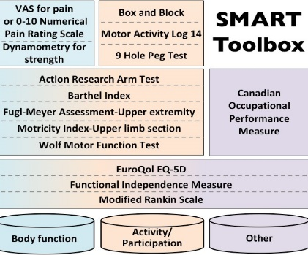

Launch of the SMART toolbox by Julie Duncan Miller

Find us on the web! www.nmahp-ru.ac.uk

Contact NMAHP-RU

GCU
Kim.Stewart@gcu.ac.uk 0141 331 8100
Govan Mbeki Building, Glasgow Caledonian University, Cowcaddens Road, Glasgow, G4 0BA

Stirling
Karen.Stanton@stir.ac.uk 01786 466341
Unit 13 Scion House, University of
Stirling Innovation Park, Stirling, FK9 4NF

Did you know that one stroke occurs every 3 ½ minutes in the UK? And of the 1.2 million stroke survivors in the UK, up to 77% will experience problems with the arm, shoulder, or hand? Upper limb (arm) dysfunction following stroke is a big issue. The early phases of my PhD study found
the capture of important
outcomes in arm rehabilitation trials was inconsistent, and a wide range of measures were being used.
My PhD focused on agreeing international consensus recommendations to address this: The SMART toolbox. It is the result of international consensus activities (eDelphi) involving researchers and clinicians from 18 different countries to agree on important
measures. We also completed 16

Recent publications

focus groups and eight interviews with 111 stroke survivors, carers and clinicians from across
Scotland to identify important outcomes. Finally, we organised a consensus meeting for stroke survivors and carers, and
international clinicians and researchers, to agree on the measures to include in the SMART toolbox.
The SMART toolbox provides a
pool of 15 outcome measures for use in future stroke upper limb rehabilitation trials.
Choosing measures from a toolbox of valid, reliable measures that capture important outcomes will
strengthen arm rehabilitation research, enhancing inter-study comparisons and
amalgamation of data for
efficacy analyses. This will help clinicians to identify the most
effective treatments for their patients and ultimately, improve life following stroke.
We launched the SMART
toolbox at the European Stroke Organisation Conference 2018 (see pic) and it’s already been used in trial design.
Our first article from the study was just published and is available here . I was invited to write a blog for Evidently Cochrane - available here .

Melone, L., Price, L., Ness, V., Simpson, L., MacDonald, J., and Reilly, J. (2018) The effect of fake tan on hand hygiene practice. Journal of Infection Prevention, 19 (6), pp. 266-269. https://doi.org/10.1177/1757177418769380
Pollock, A., Campbell, P., Struthers, C., Synnot, A., Nunn, J., Hill, S., Goodare, H., Morris, J., Watts, C. and Morley, R. (2018) Stakeholder involvement in systematic reviews: a scoping review. Systematic Reviews, 7, pp. 208. https://
doi.org/10.1186/s13643-018-0852-0
Price, L., Melone, L., Cutajar, E., Blane, L., Gozdzielewska, L., Young, M., McAloney-Kocaman, K. and Reilly, J. (2018) Investigating the effect of preparation for and participation in a hand sanitizing relay on nursing students' ability to recall the WHO six-step hand hygiene technique. American Journal of Infection Control, 46 (11), pp. 1304-1306. https://
doi.org/10.1016/j.ajic.2018.04.222
Lennon, O., Blake, C., Booth, J., Pollock, A. and Lawrence, M. (2018) Interventions for behaviour change and self- management in stroke secondary prevention: protocol for an overview of reviews. Systematic Reviews, 7, pp. 231. https://
doi.org/10.1186/s13643-018-0888-1
Brady, M. and Focus Trial Collaboration. (2019) Effects of fluoxetine on functional outcomes after acute stroke (FOCUS): a pragmatic, double-blind, randomised, controlled trial. Lancet, 393 (10168), pp. 265-274. https://doi.org/10.1016/S0140-
6736(18)32823-X
Duncan Millar, J., van Wijck, F., Pollock, A. and Ali, M. (2019) Outcome measures in post-stroke arm rehabilitation trials: do existing measures capture outcomes that are important to stroke survivors, carers, and clinicians? Clinical Rehabilitation (e- Pub Ahead of Print) https://doi.org/10.1177/0269215518823248
Sinesi, A., Maxwell, M., O’Carroll, R. and Cheyne, H. (2019) Anxiety scales used in pregnancy: systematic review. BJPsych Open, 5 (1), pp. 1-13. https://doi.org/10.1192/bjo.2018.11
Wylie, G., Torrens, C. and Campbell, P. (2019) Podiatry interventions to prevent falls in older people: a systematic review and meta-analysis. Age and Ageing (e-Pub Ahead of Print) https://doi.org/10.1093/ageing/afy189

Directors Blog:
Welcome back to the NMAHP Research Unit newsletter following a recent break during which we successfully completed a 7-year Scientific Review by the Chief Scientist Office and revised our programmes of work into 3 areas:
Innovation in NMAHP interventions; Transforming care delivery;
Maximising data usage in NMAHP research.

The Unit continues to pursue cross cutting workstreams, which feed into these programmes, in the areas of: Stroke (rehabilitation); Pelvic Health; Maternal and Child Health; Health Behaviour Change; Long Term Conditions; and Innovations in Services, Systems, and Roles. The Unit has continued to pursue its objectives through the award of research grants, publication of academic papers, dissemina- tion through innovative mechanisms to reach our patient, public, policy and practice colleagues, and developing capacity and capability for NMAHP research. There is so much activity underway in all
these areas that we would encourage you to visit our website to learn more.

Best Wishes, Margaret Maxwell.

