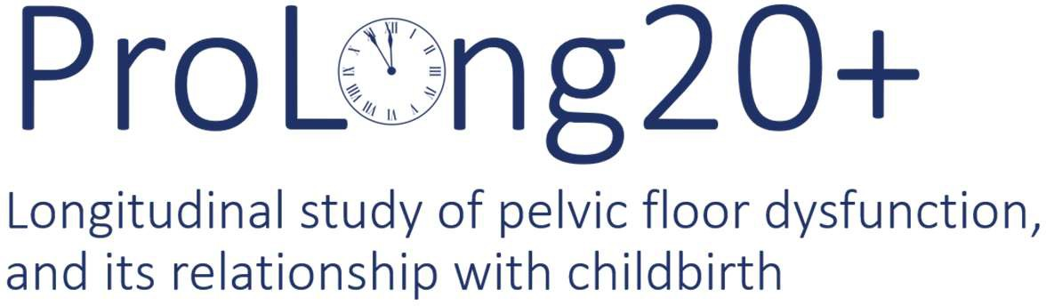

PRIVACY NOTICE
The purpose of this privacy notice is to explain to people taking part in the ProLong20+ study how their personal information will be used. Glasgow Caledonian University is the sponsor for the study and will act as the data controller for this study.

Data Controller’s contact details | ProLong20+ Study  Nursing, Midwifery and Allied Health Professions Research Unit (NMAHP RU)  Glasgow Caledonian University Cowcaddens Road  Glasgow G4 0BA  p rolong@gcu.ac.uk
ProLong20+ Study Chief Investigator’s contact details | Professor Suzanne Hagen s..hagen@gcu.ac.uk
Data Protection Officer’s contact details | The Data Protection Officer for Glasgow Caledonian University can be contacted at:  Data Protection Officer Glasgow Caledonian University G4 0BA dataprotection@gcu.ac.uk
The purposes of the processing | The aim of the ProLong20+ study is to build on the information already gathered in order to find out more about the life history of pelvic floor dysfunction following child birth. Pelvic floor dysfunction includes incontinence (bladder or bowel), prolapse and sexual dysfunction. The group of women who will be invited to take part in the ProLong20+ study have been studied since 1993/94, allowing a detailed history of their symptoms and experiences of pelvic floor dysfunction to be developed.  Questionnaire and pelvic floor examination results from the ProLong20+ study will be analysed together with NHS medical records (where participants have given their permission). This information will be combined with results from a similar study involving the women based in New Zealand in 2014 to report how common pelvic floor dysfunction is and how it relates to childbirth and other risk factors, particularly the menopause. Findings will help inform estimates of future need for treatment and research, and ultimately improve women’s health during and after pregnancy.

The lawful basis for the processing | G eneral Data Protection Regulation (GDPR)  Personal data will be processed under GDPR Article 6(1)(e) which allows for processing of personal data where it is necessary ‘for the performance of a task carried out in the public interest’.  Research is a statutory purpose of Glasgow Caledonian University (Part 3 of the Statutory Instrument; 2010 No. 198; Education; The Glasgow Caledonian University Order of Council 2010).  Special category personal data will be processed under GDPR Article 9(2)(j) which allows for processing of special category personal data where it is necessary for ‘research purposes’.  Approval for this research has been granted by the Chief Scientist Office, Scottish Government Health and Social Care Directorates and an NHS Research Ethics Committee (South East Scotland Research Ethics Committee 1).  C ommon law duty of confidentiality  The lawful basis for the processing of confidential information is dependent on where participants were originally recruited:  - Aberdeen: Consent and approval from The Public Benefit and Privacy Panel for Health (reference: 1718-0232), and  - Birmingham: Consent and Section 251 support (Confidentiality Advisory Group reference: 18/CAG/0200).
The legitimate interests for the processing | Not applicable as the study is not using “Legitimate Interests” as a legal basis for processing personal data.
The categories of personal data obtained | This study will collect or process the following categories of information:  - Personal data (e.g. current address, contact details). NB: Other items of personal data, such as name and date of birth, were collected in previous studies.  - Special category personal data (e.g. ethnicity, answers to questionnaire questions which relate to health, results from pelvic floor examinations, diagnosis and treatment information from medical records). Questionnaire and physical examination information gathered from the participants who took part in the previous studies will also be processed.
The source of the personal data | Up-to-date name and address information for the group of women who took part in the original study in 1993-94 will be requested from the NHS (NHS National Services Scotland and NHS Digital)ª prior to sending out study questionnaires. This information will be used for the sole purpose of contacting previous ProLong study participants currently living in the UK at the correct address. The NHS (NHS National Services Scotland and NHS Digital)ª will inform the study team if any participants have died or moved abroad so that we do not try to contact them. The postcode supplied will be stored for those participants who indicate that they would be willing to be contacted again in the future by the research team. All other current address information obtained will be deleted once the current study is complete. No information will be requested for women who have previously indicated that they no longer wish to be contacted by the study team.  In addition to the information collected using questionnaires and pelvic floor examinations, selected information from participants’ medical records will be accessed from the NHS (NHS National Services Scotland and NHS Digital)ª for those participants who give their agreement. The information requested will be diagnosis and treatment information relating to pelvic floor dysfunction. This medical records information will be supplied to the study team on one occasion after the end of the postal survey.  The NHS medical records of those participants who agree to have a pelvic floor examination will be accessed by the NHS hospital staff carrying out or supervising that examination solely in relation to that examination.  NB: None of the information accessed from the NHS is publicly available.
The recipients or categories of recipients of the personal data | - NHS -personal data will be sent to the NHS (NHS National Services Scotland and NHS Digital)ª for the following purposes:  - M edical Record Access - Selected information from  medical records related to pelvic floor dysfunction will be requested from the NHS for those women who agree to this access when completing the study questionnaire.  - F uture Studies - There may be further studies related to this research in the future. Before sending out any invitation letters, the research team will request up-to- date name and address details from the NHS for those women still living in the United Kingdom and who have indicated that they would be willing to be contacted again in the future.  The identifiable information sent will be name, date of birth, postcode and NHS or CHI number.  - O ther research teams - It is possible that data collected in this study may be used to support future health research. For example, it may be combined with information collected by other long-term studies of women and pelvic floor dysfunction. Any data leaving the ProLong20+ study team for this purpose will be fully anonymised according to the guidelines issued by the Information Commissioner’s Office (ICO), so that participants cannot be identified.
The details of transfers of the personal data to any third countries or international organisations | No personal data will be transferred to countries outside the EU or international organisations.
The retention periods for the personal data | 10 years. After this time all personal data held by the ProLong20+ study team will be fully anonymised so that participants are not or no longer identifiable.

The rights available to individuals in respect of the processing | Your rights to access, change or move your information are limited, as we need to manage your information in specific ways in order for the research to be reliable and accurate.
The right to withdraw consent | If you withdraw from the study, we will keep the information about you that we have already obtained. To safeguard your rights, we will use the minimum personally-identifiable information possible.  You can withdraw from the study at any point by contacting us in writing, or by telephone or e-mail using the contact details below:  ProLong20+ Study NMAHP Research Unit  Glasgow Caledonian University Cowcaddens Road  Glasgow G4 0BA  Tel: 0141 331 8835  p rolong@gcu.ac.uk  You do not have to give a reason for withdrawing and your decision to withdraw will not affect the care you receive in any way.
The right to lodge a complaint with a supervisory authority | If you wish to raise a complaint on how we have handled your personal data, you can contact our Data Protection Officer who will investigate the matter. If you are not satisfied with our response or believe we are processing your personal data in a way that is not lawful you can complain to the Information Commissioner’s Office (ICO).  Information Commissioner's Office Wycliffe House  Water Lane Wilmslow Cheshire SK9 5AF  Tel: 0303 123 1113 (local rate)  h ttps://ico.org.uk/global/contact-us/
The details of whether individuals are under a statutory or contractual obligation to provide the personal data | You are under no obligation to complete the questionnaire or attend for a pelvic floor examination. Your care will not be affected by whether you take part in this study or not.
The details of the existence of automated decision-making, including profiling | Not applicable. None of the data collected in this study will be used for automated decision-making or profiling of participants.
ProLong20+ Privacy Notice for Website v1.6 2019-07-01.docx

a NHS National Services Scotland for those participants originally recruited in Aberdeen or NHS Digital for those
recruited in Birmingham. NHS National Services Scotland and NHS Digital are the parts of the NHS which collect health information from across the health and social care systems in Scotland and England/Wales respectively.

