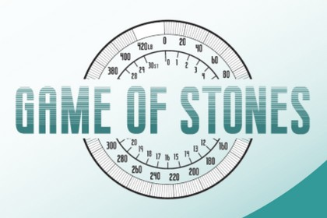
J U N E 2 0 2 2

Newsletter

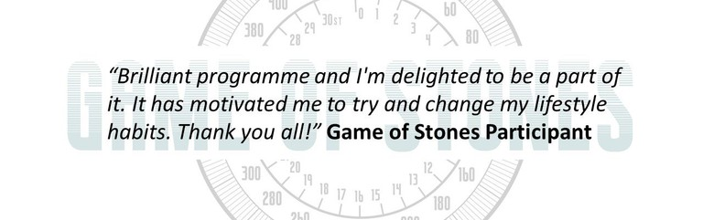
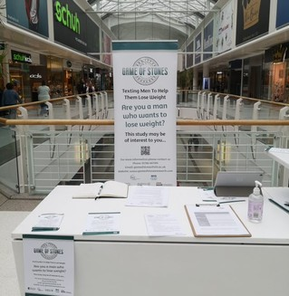
585

men recruited
across Belfast, Bristol and Glasgow
Game of Stones is now full!
Over the last 10 months our research teams in Belfast, Bristol and Glasgow have been carrying out recruitment and our trial is now full. We'd like to thank the men taking part, and apologise to those who showed interest after we were full. Starting recruitment during Covid restrictions posed challenges, particularly in terms of access to venues. We are very grateful to the GP surgeries who used their constrained time to support the trial. Community venues across the three cities were pivotal in us attaining full recruitment and in enabling us to carry out data collection. Interestingly, advertising on social media (Facebook and Instagram) generated interest in the trial, particularly in the final couple of months of recruiting!

What happens after signing up?
Follow our progress on: www.gameofstonesresearch.com
Funded by NIHR Public Health Research [REF 129703]
In this trial, men are allocated to one of three groups. Every group has their baseline - the first appointment with the research team. All 585 baselines have taken place now. Depending on the group, we might see men at 3 months and 6 months as well. Everyone is invited to a 12 month appointment and a 24 month appointment. The first 12 month appointment is scheduled for the end of June.

Meet the Team
Each newsletter we will introduce you to some of the team who are making the Game of Stones Trial possible.

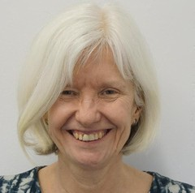
Pat Hoddinott University of Stirling
Pat is the Chief Investigator of Game of Stones. A GP by background, her research focuses on supporting people to adopt and sustain behaviours which improve health and wellbeing. She co-lead a small-scale Game of Stones feasibility trial in 2017. It found that men were in favour of receiving text messages to help them lose weight. The feedback men gave, helped design the content of the Game of Stones full trial.

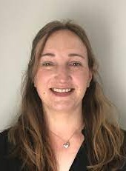

Lisa Macaulay University of Stirling
Catriona and Lisa are the Trial Managers for Game of Stones. If you've signed up to the trial you've probably had an email or call from one of them! They are responsible for the day to day running of the trial across all the research sites. Expert problem solvers, they play a huge role in keeping the trial running smoothly.

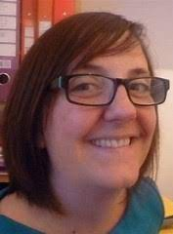
Catriona O'Dolan University of Stirling

Mark is the Senior IT Development Manager at the Health Services Research Unit at the University of Aberdeen. He and the team up at HSRU have been making sure all the forms we need work online and talk to each other - meaning our participants can use a tablet to fill out their questionnaires knowing their data is being kept safe.
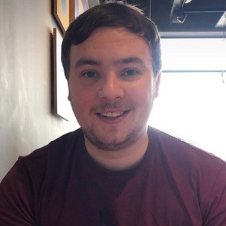

Mark Forrest University of Aberdeen

Jack Gilmore University of Dundee
Jack is a Senior Software Developer at the Health Informatics Centre at the University of Dundee. Sadly for us, he is leaving for another job however he has been one of the behind the scenes faces who, amongst lots of other things, makes sure the men in the trial receive their automatic text messages!

