Newsletter
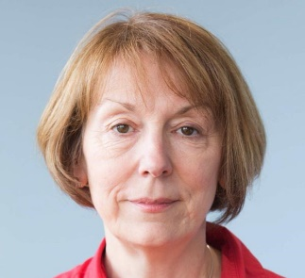
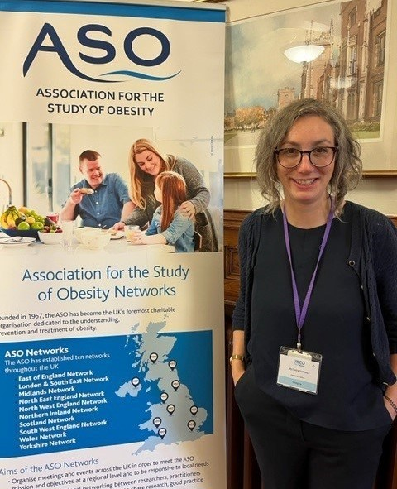

In brief:

Volume 5, Issue 4. 31/10/23
- From October 2023 through till end of our CSO funding in March 2024, Prof H Cheyne will be Co-Director of the NMAHP-Research Unit alongside Prof. M Maxwell (who will reduce to part-time working). Congratulations Prof.Cheyne!

Game of Stones news
By Lisa Macaulay

- Dr Lynne Gilmour and Joshua Cathcart have started work on the Tenovus award which seeks to co-develop a research proposal with children and young people who are or have experienced suicidal thoughts and behaviours, as well as a range of stakeholders who work with this group of young people.

The Game of Stones trial has received additional funding from NIHR for an 8 month costed
extension, with additional NIHR funded projects on mental health and
multiple long-term conditions alongside. This trial started during the Covid-19 pandemic and has successfully
recruited and followed up men to 12 months. The
team welcomes the news to enable maximum benefit from the trial.

The Game of Stones
team travelled to Belfast in September to attend
the UK Congress on
Obesity conference. Claire Torrens presented some preliminary qualitative findings

EU Horizon PROSPERH study By Margaret Maxwell

Promoting Positive Mental and Physical Health at Work in a Changing Environment: A Multi-level Approach (EU Horizon PROSPERH study). Recent years have seen rapid changes in the workplace arising from ‘digital’ and ‘green’ transitions, as well as the COVID-19 pandemic. New forms of work and work management can affect the physical and mental health of workers in new ways (both positive and negative) but are not yet well understood. Following on from the current EU Horizon 2020 MENTUPP study which tackled mental health in the workplace, PROSPERH will first gather robust evidence (using literature and high-quality datasets such as the UK Household Longitudinal Study) on what influences mental and physical health in the workplace.
Based on this evidence and building on existing interventions, the project will refine/develop and validate a multi-level (on-line) intervention. Delivering health promotion, online self-monitoring & self-management, and advice on referral pathways, content will be tailored for three sectors experiencing significant change (telework and ICT-based mobile work (TICTM), healthcare, and construction).
A multi-centre cluster RCT trial will be conducted in 10 European countries (and Australia) to determine effectiveness and cost effectiveness of the intervention. PROSPERH (led by University College Cork and involving 18 partners across 13 countries) will begin in January 2024 with the NMAHP-RU at University of Stirling involved in 3 of its Workpackages.
entitled ‘Experiences of a text message delivered behavioural weight management
intervention (with or
without financial incentives for men living with obesity), and their co-morbid mental health problems.’

The conference included some interesting sessions on UK obesity policy, the role of schools in managing obesity, maternal obesity, weight stigma, whole system approaches and some
really insightful
presentations from those with lived experience. The conference provided an opportunity to network
with others in the field as well as a long overdue Covid delayed site visit to meet our colleagues at Queen’s University Belfast.
Inside this issue:
Game of Stones news  By Lisa Macaulay | 1
EU Horizon  PROSPERH study  By Margaret Maxwell | 1
AMID study update  By Kirsteen Goodman | 2

AMID study update (Abdominal Massage in people with Intellectual
- Congratulations to Prof. Suzanne Hagen and
Prof. Alex Todhunter- Brown for being recognised as being in the top 2% of cited scientists in their respective research
fields of Obstetrics and Reproductive Medicine and Rehabilitation. This is based on a composite score of impact
(citations) rather than productivity (number of publications) and it also incorporates information on co-authorship and author positions (single, first, last author). An amazing reflection of
their international
esteem and that of the NMAHP-RU.

- Barbara Farquharson presented work from her BHF Fellowship at the
Scottish Cardiac Arrest Symposium on Friday 6th October, an amazing event bringing together
300+ people dedicated to improving survival from cardiac arrest.

Find us on the web! www.nmahp-ru.ac.uk @NMAHPRu

Contact NMAHP-RU

GCU
nmahpruadmin@gcu.ac.uk 0141 331 8100
Govan Mbeki Building, Glasgow Caledonian University, Cowcaddens Road, Glasgow, G4 0BA

Stirling
nmahp.ru@stir.ac.uk 01786 466341
Pathfoot Building, University of Stirling, Stirling, FK9 4LA
Disabilities) By Kirsteen Goodman

In September we said bye to Jennifer who was the researcher on AMID. She was integral in the
recruitment and delivery of the project and her passion for trying to improve the
quality of life for people with learning disabilities was so clear to see. One of our PPI representatives on the study, Karen Jankulak shared her lived experience and insight into the impact constipation has on those with learning disabilities; “My son, Huw, is 20 years

Recent publications
old and is profoundly autistic, with virtually no communication. It took a
very long time to discover, and quite a long time to manage, his chronic constipation, but now that this is being done successfully, his quality of life has massively
improved in every possible way. His behaviour, in
particular, is far less risky and we can be much more bold in what we try to do with him—this enriches his life”
The study has been looked on very favorably by the NHS collaborators in GGC and NHS Lanarkshire, who have both seen an increase in the referrals for abdominal massage since
the study. We have also had really positive feedback from people who took part (participants and
carers). The data analysis for the study is under way and we hope to have the full results by the end of the year and I look forward to sharing these findings with you all!

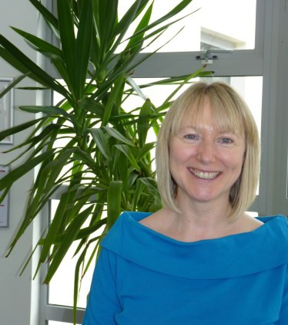
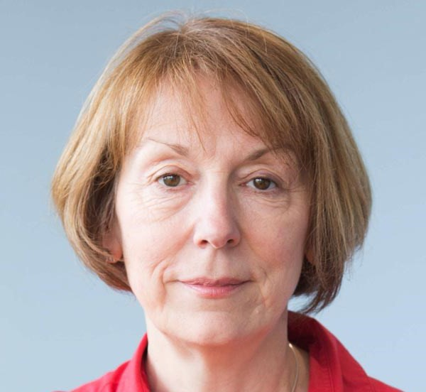
  - Arensman, E., Leduc, M., O’Brien, C., Corcoran, P., Griffin, E., Leduc, C., Coppens, E., Tsantila, F., Ross, V., Abdulla, K., Hauck, P., Amann, B.L., Aust, B., Pashoja, A.C., Cresswell-Smith, J., D’Alessandro, L., Fanaj, N., Greiner, B.A., Luyten, J., Mathieu, S., Maxwell, M., et al. (2023) Implementation and evaluation of a multi-level mental health promotion intervention for the workplace (MENTUPP): study protocol for a cluster randomised controlled trial. Current Controlled Trials in Cardiovascular Medicine, 24 (1), pp. 621.
  - Brown, S.E., Scobbie, L., Worrall, L., McMenamin, R. and Brady, M.C. (2023) Access G-AP: development of an accessible goal setting and action planning resource for stroke survivors with aphasia. Disability and Rehabilitation, 45 (13), pp. 2107-2117.
  - Glennie, N., Harris, F.M. and France, E.F. (2023) Perceptions and experiences of control among people living with motor neurone disease: a systematic review and thematic synthesis. Disability and Rehabilitation, 45 (16), pp. 2554-2566.
  - Janiszewska, I. and Whittaker, A. (2023) A qualitative systematic review of mental health among
haemodialysis patients. Journal of Kidney Care, 8 (5).
  - King, E., Dick, S., Hoddinott, P., Malcolm, C., France, E., Kyle, R.G., Aucott, L., Wilson, P. and Turner,
S. (2023) Regional variations in short stay urgent paediatric hospital admissions: a sequential mixed- methods approach exploring differences through data linkage and qualitative interviews. BMJ
Open, 13 (9), pp. e072734.
  - King, E., Lamont, K., Wendelboe-Nelson, C., Williams, C., Stark, C., van Woerden, H.C. and Maxwell,
M. (2023) Engaging the agricultural community in the development of mental health interventions: a qualitative research study. BMC Psychiatry, 23 (1), pp. 399.
  - Shepherd, A., Newman, D.K., Bradway, C., Jost, S., Waddell, D., Mackay, W.G. and Hagen, S. (2023) Impact of Practice on Quality of Life of those Living with an Indwelling Urinary Catheter – An International Evaluation. Urologic Nursing, 43 (4), pp. 162-172.

Co-Directors Blog:
You will have seen from the news item that as longstanding Director I will now be supported by my colleague Prof. Helen Cheyne as Co-
Director for the remaining 6 months of our CSO
funding. This is our joint blog.

We have a fair bit of work ahead of us to see the Unit transition to new arrangements at each host HEI (Glasgow Caledonian University and University of Stirling). Whilst transition arrangements are still being discussed all we can say at this moment is that the more formal partnership (facilitated by the CSO core funding) will not be carried forward after March 2023. The NMAHP-RU, certainly in its name and current remit and function, will cease to exist.
However, all our staff and all our research, built up over 30 years with CSO support, will continue and develop at each HEI (more of this will be revealed in our final January Newsletter). Those who have benefitted from CSO support will continue to nurture and
support the careers of others. Over the next 5 months we will be collating and celebrating all that has been achieved (there will be a final report to watch out for) as we look to the future and see the next generation of NMAHP researchers flourish.
Best Wishes, Margaret Maxwell & Helen Cheyne

